**LeNet for Traffic Signs**

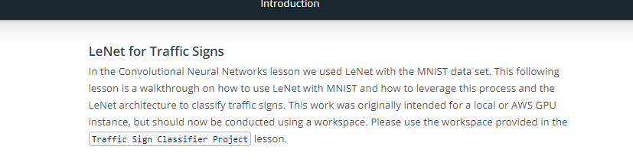

Link Video LeNet Architecture: <https://www.youtube.com/watch?v=FQYrzmnbsMs>

Link Video LeNet Data: <https://www.youtube.com/watch?v=eCP8o1BnhRA>

Link Video LeNet Implementation: <https://www.youtube.com/watch?v=EA3f6zTbbo0>

Link Video LeNet Training Pipeline: <https://www.youtube.com/watch?v=yof-J8Xktlk>

Link Video LeNet Evaluation Pipeline: <https://www.youtube.com/watch?v=cibEsIOTE60>

Link Video LeNet Training the Model: <https://www.youtube.com/watch?v=9580p7ZRQVY>

Link Video LeNet Testing: <https://www.youtube.com/watch?v=NHoyQSZNWA4>

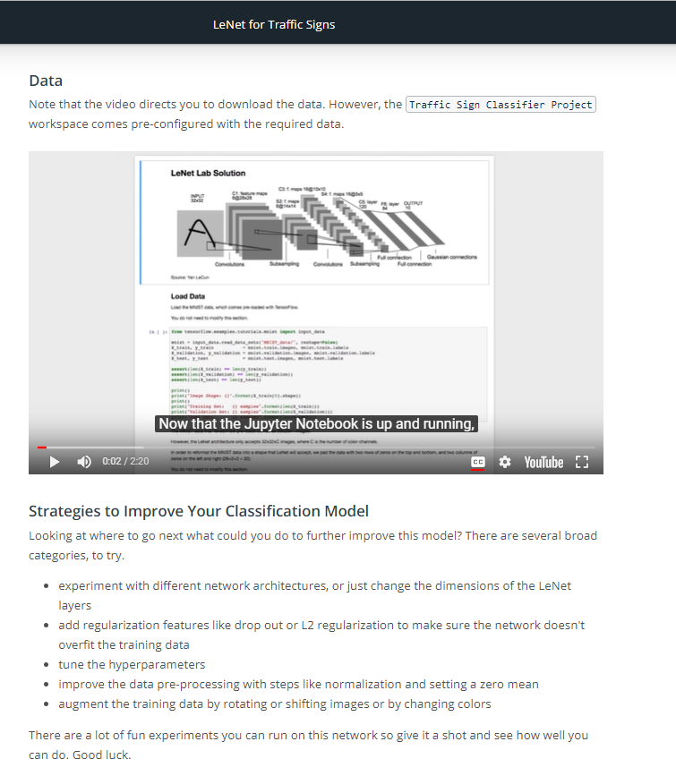

Link Video LeNete for Traffic Signs: <https://www.youtube.com/watch?v=NHoyQSZNWA4>

